DAI LOC DEPARTMENT OF EDUCATION & TRAINING  DOAN NGHIEN PRIMARY SCHOOL  Full name: …….……………………………  Class: 5…………… | THE FIRST SEMESTER TEST  Subject: English – Grade: 5  Time: 40 minutes  School year: 2020-2021
Marks | Comment(s) | Listening | Reading | Writing | Speaking

PART 1. LISTENING ( 20 minutes)
Question 1. Listen and number. There is an example (1 pt)

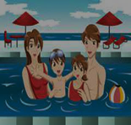



A

0
A B C D E

Question 2 Listen and tick (√) Yes (Y) or No (N). There is an example.(1pt)
 | Yes | No
0. Mai has English every day. |  | V
1. Nam has four lessons.
2. Akiko is at school.
3. Quan has Maths four times a week.
4. Tony is going to play table tennis on Sports Day

Quesion 3. Listen and match. There is an example.(1pt)

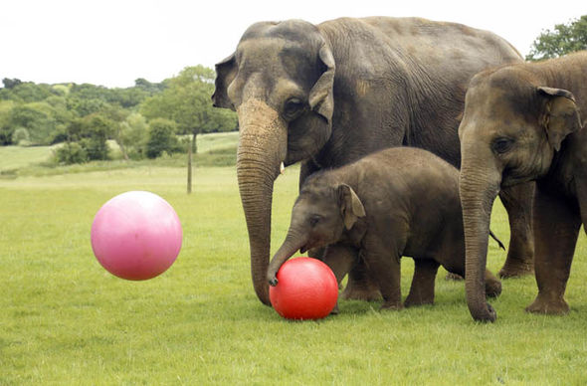
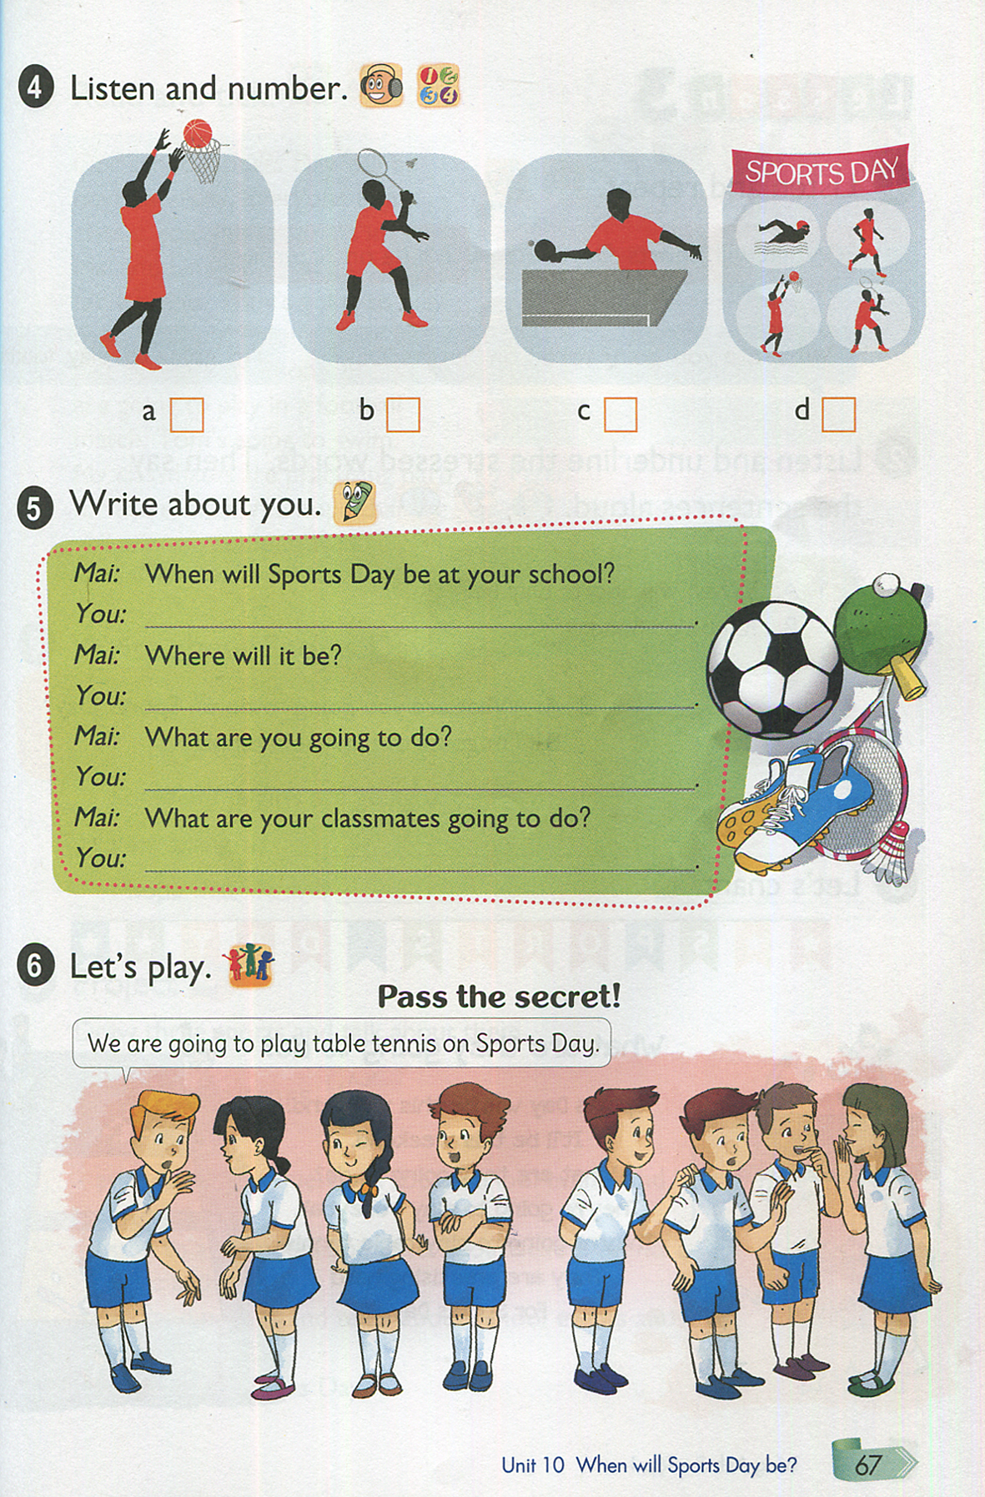
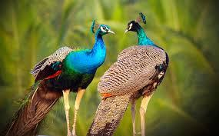

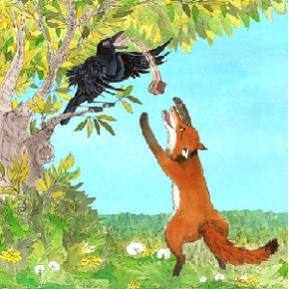
A B C D E

2
0 1 3 4

Question 4. Listen and tick () the correct pictures. There is an example. (1pt)
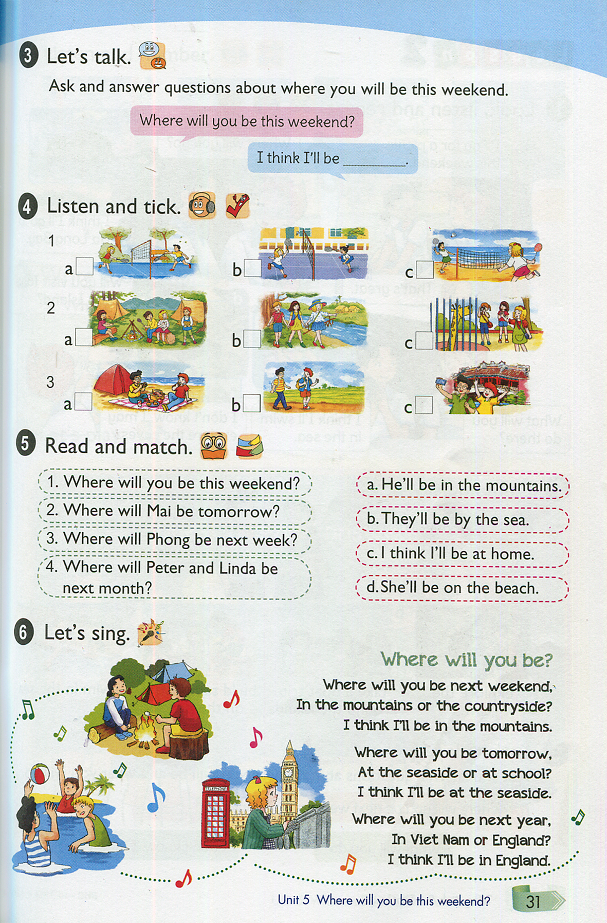
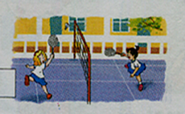

0.a b. c. V
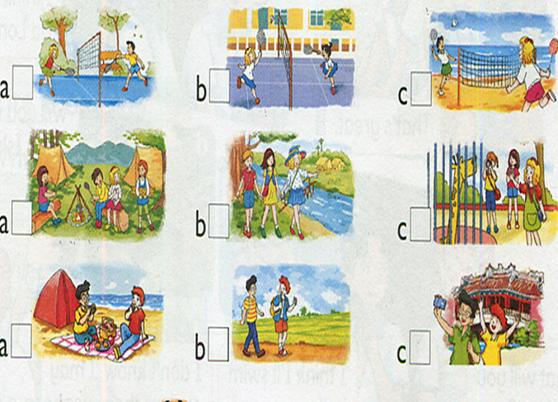

1.a b. c.

2.a b c.
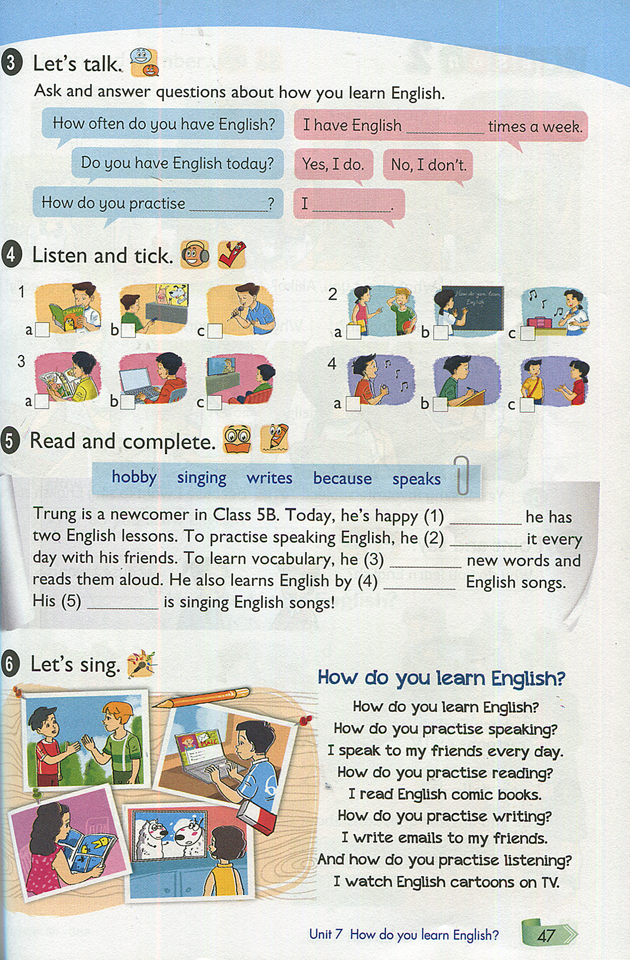

3.a b c.

4.a b. c.

Question 5: Listen and complete. There is an example. (1pt)

0. A: How do you practice listening?  B: I often watch cartoons on TV.  1. A:What are you going to do on Sports Day?  B: I ‘m going to play badminton  A: I like ……………too. Let’s play together.  2. A: What subject do you like best, Nam?  B: English. It’s my favourite subject.  A: How often do you have English?  B: I have it …………..times a week. | 3. A:What are you reading ,Tom?  B: …………………. ………….  A: What do you think of the main character?  B: She is very kind.  4. A: Where were you yesterday?  B: I was at the park.  A: What did you see there?  B: I saw a lot of ………………  A: I love them  B: Me too. They moved so beautiful.

PART II. READING AND WRITING (20 minutes)
Question 6. Look and read. Choose the correct word and write it on the line. (1pt)

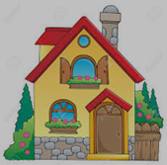 |  |  |  | 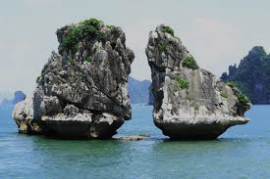
house | doctor | comic books | lion | Ha Long Bay

0. Your family live in it. ...house....
1. He works in the hospital. He’s a .............. ..
2. Most of children like reading them. .................
3. This is a favourite place to go on a picnic . .................
4. It’s a kind of animals, it’s also “King of jungle” ..................
Question 7: Write the missing words on the line. (1pt)



Teachers' Day in Viet Nam is on (0) November 20th. It is an occasion for us to honour our teachers for their contribution to education. on that day, we give cards and (1) f_ _ _ _ _ _ to our teachers. We dance and sing songs to (2) t _ _ _ _ _ them for their lessons. We especially love our English (3) t _ _ _ _ _ _ because she's a (4) w _ _ _ _ _ _ _ _ teacher.

Question 8. Read and write one or more words on the line to complete the sentences. (1pt)
Favourite books
Name | Kind of story | Name of story | Main character | Character
Mary | fairy tale | Ali Baba and the Forty Thieves | Ali Baba | clever, brave
Tony | Detective | Jimmy Kudo | Jimmy Kudo | intelligent, brave
Phong | fairy tale | Thanh Giong | Thanh Giong | brave, strong
Nam | fairy tale | The Legend of Watermelon | An Tiem | hard-working

1. Mary’s favourite story is ____________________________
2. The main character of Thanh Giong is __________________
3. Jimmy Kudo is a ________________ story.
4. An Tiem’s character is ________________.

Question 9: Look and read. Choose the correct words to write on the line. (1pt)

My name is Mai. I love reading English story. I read (0) comic book every week. When I find new words I write them in my (1)……………………I say the words and spell them
a few times. I often stick new words on my (2)……………………. walls and practise using them. I learn to speak English by talking English with my (3)……………. everyday. May be I will join an (4) …………………… to improve my English speaking.

 |  |  | 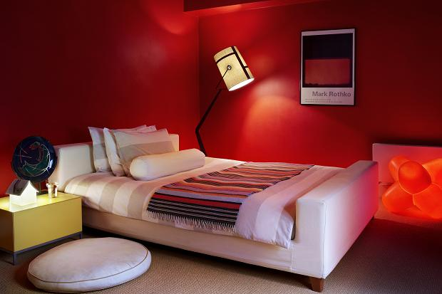 | 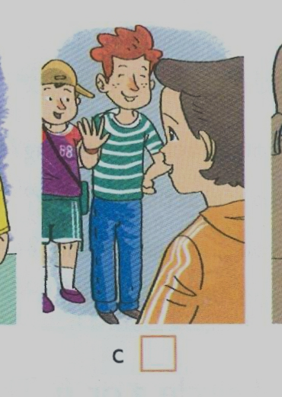
notebook | comic books | English club | bedroom | friends

PART III. SPEAKING (1pt )
1. Interview .
2. Let’s talk
3. Describing the picture.

Question 1. Interview. There is an example.

To do/ To say | Response | Back-up (Sự hỗ trợ)
Teacher (T) ask 5 questions about personal informations:  T ask 2 questions:  What’s your name?.  How do you spell your name?.  (or How old are you?.)  T ask 3 questions:  What do you do in the morning/afternoon/evening?  How many people are there in your family?  Who is your close friend?  (or How many pets do you have?  What pet do you like?  What is your favourite subject?  What are your favourite food and drink?) | My name’s Minh.  M-I-N-H  I’m eleven years old.  I do morning exercise/play football/do my homework.  There are five people in my family.  Thu is my close friend.  (I have two pets: one dog and one cat.  I like dog.  My favourite subject is English.  My favourite food and drink are chicken, beef and orange juice.) | Do you go to school, have breakfast/do morning exercise?/play badminton, play football/ do homework, watch TV.

Question 2. Let’s talk. There is an example.
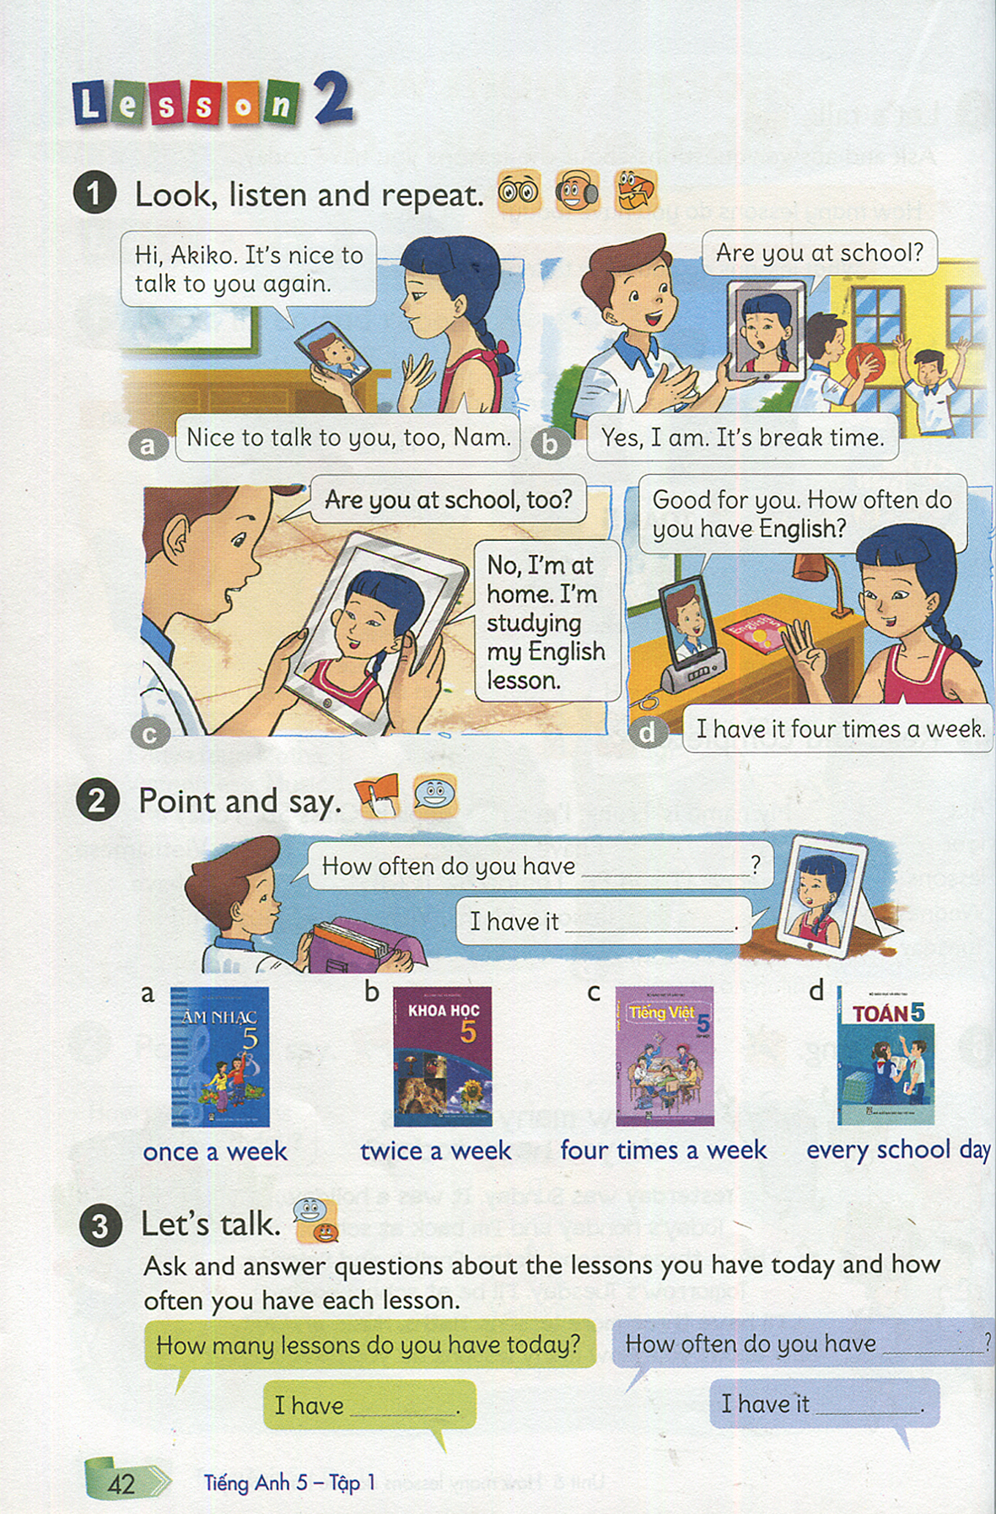 | 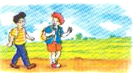 | 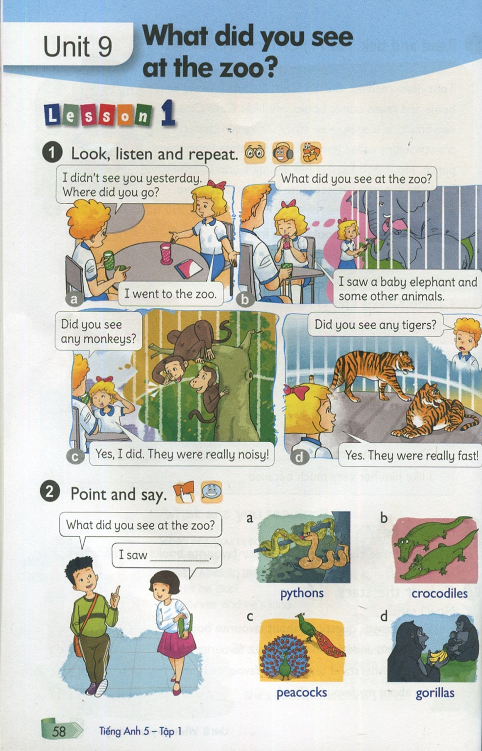 | 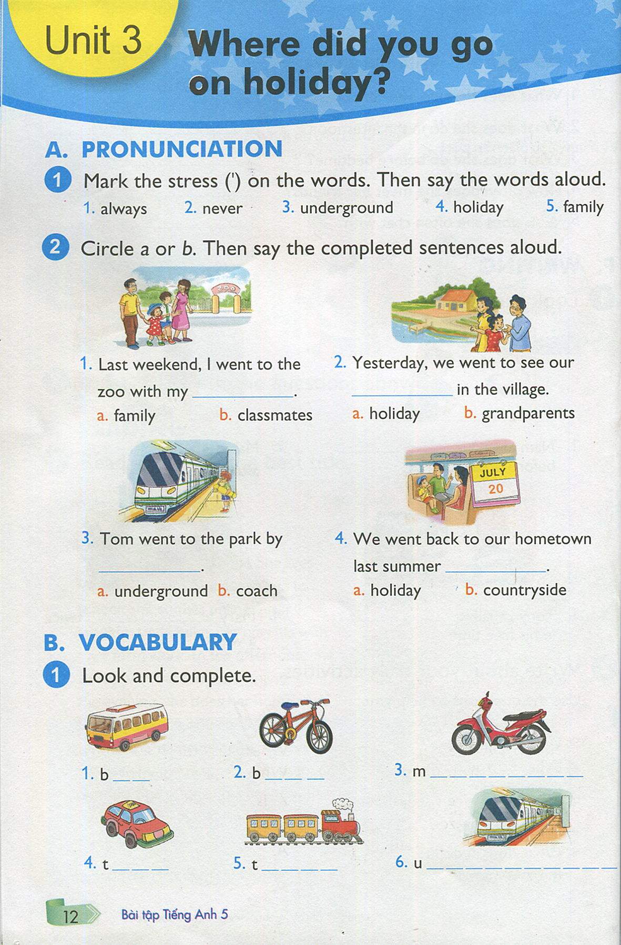

To do/ To say | Response | Back-up (Sự hỗ trợ)
- Teacher (T) shows card 1 (Music book)  T says: Now, look at this card.  - Teacher (T) shows card 2 (picture about countryside)  T says: Now, look at this card.  - Teacher (T) shows card 3  (Picture about an animal)  T says: Now, look at this card.  - Teacher (T) shows card 4  (Picture about motorbike)  T says: Now, look at this card. Image you went to Da Nang last weekend.  * 1 more question : | Student  I have Music twice a week.  I live in the countryside.  They’re peacocks.  I went by motorbike..  Yes/No | How often do you have Music?  Where do you live? (What’s it like?)  What animals are these at the zoo?  How did you get there?  Do you like Music? (Why do you learn Music?)

Question 3. Look at the picture and describe it. There is an example.

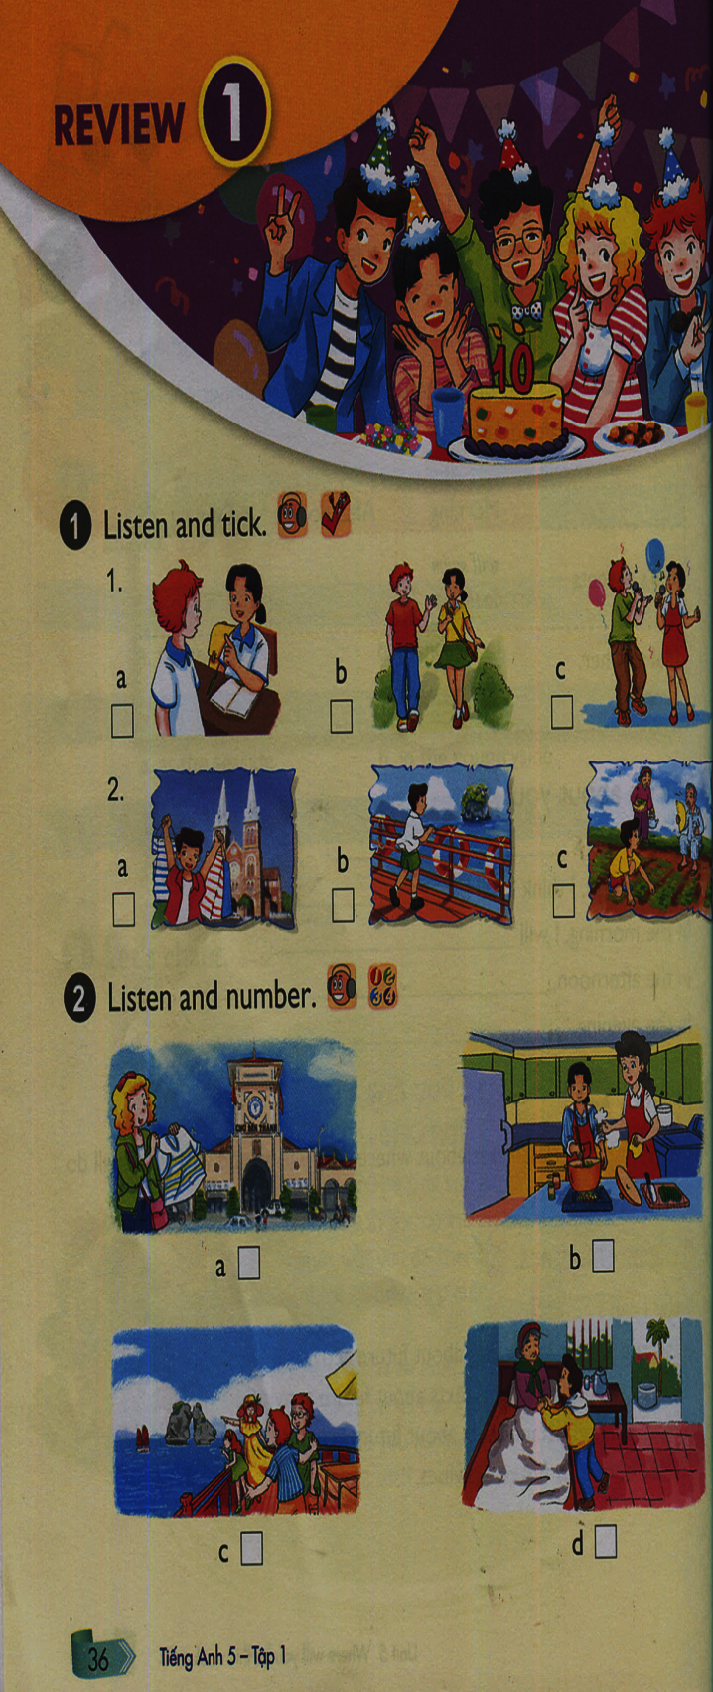 | 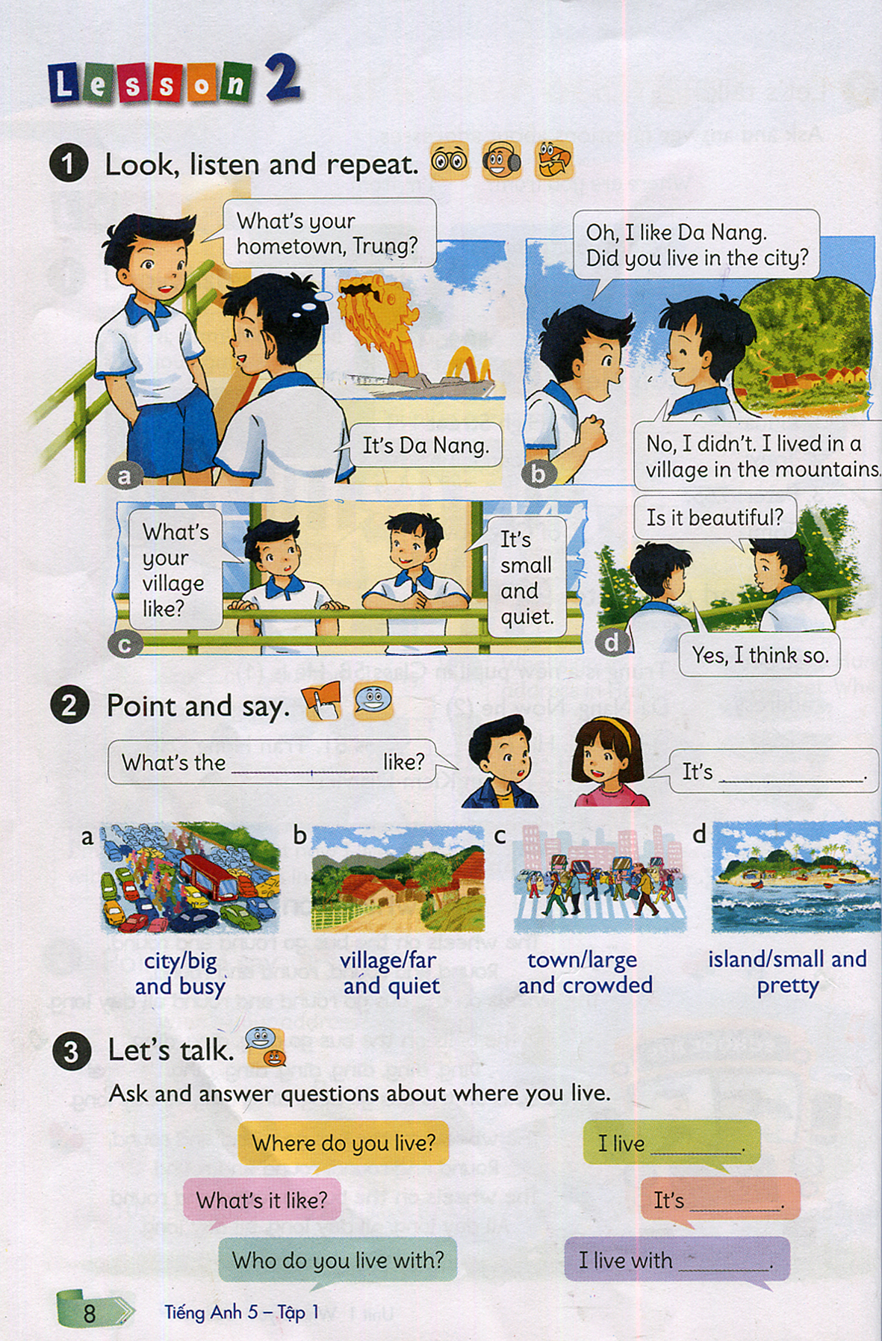

Card 5 Card 6

To do/ To say | Response | Back-up
-Teacher (T) shows card 5 (Ho Chi Minh city) or 6 ( city)  T says: Now, look at this card and describe it. | Point to the cards. Says out the corresponding words/ sentences  I’m going to Ho Chi Minh city.  I will buy…/ visit…..  Yes/No  It’ll be great/wonderful/amazing.  Yes/No  Who do you live with?  Do you live in city/ countryside?  Is it noisy/ quiet ? | Where are you going next weekend?  What will you do there?  1 more questions: Do you like visiting there? (What will your holiday be like? How? Great/Wonderful/Amazing?)  1 more question: Why do you like living there?

THE END

