DAI LOC DEPARTMENT OF EDUCATION & TRAINING …………….PRIMARY SCHOOL  Full name: …….……………………………  Class: 2………………… | THE SECOND SEMESTER TEST  Subject: English – Grade: 2  Time: 35 minutes  School year: 2020- 2021
Marks: | Comment(s)

I. Listen and circle (1m).
1. a. bl b. br 2.a. cl b. ch
3.a. ch b. sh 4.a. cl b. bl
II. Listen and tick. (2ms)
 |  |  | 
1. a | b. | 2. a. | b.

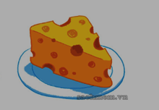 |  | 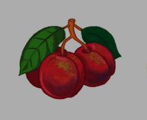 | 
3. a | b. | 4. a | b.

III. Listen and tick (V) or cross (X). (2ms)
1   | 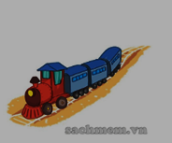  2 | 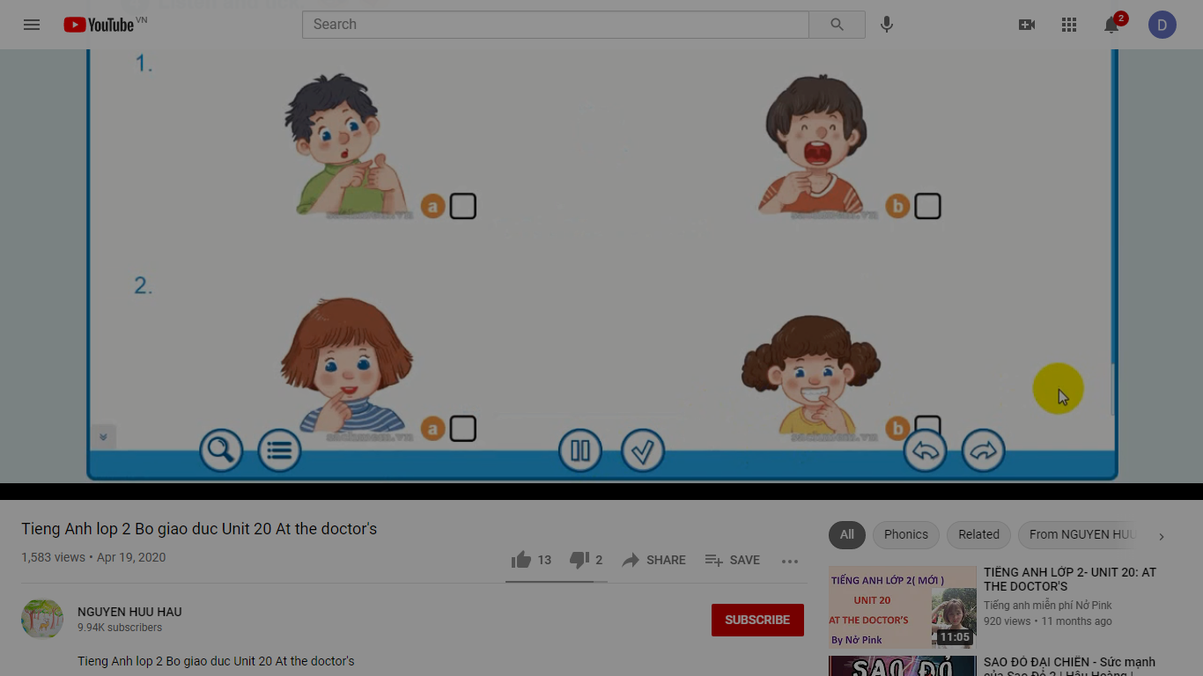  3 |   4

IV. Read and tick (V). (2ms)
1.These are plates.  2. It’s a trolley. |   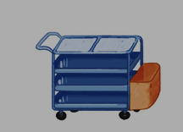  a |   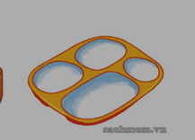  b
 | a | b
3. He’s my brother. |   a |   b
4. They are singing. |   a |   b
V. Write the missing letters .(2ms)
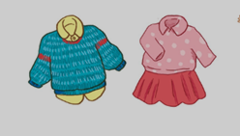  0. | Clothes.
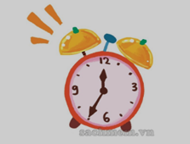  1. | _ _ ock
  2. | fea_ _ ers
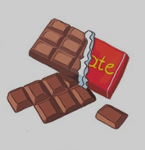  3. | _ _ ocolate
  4. | _ _ ossom
VI. Speaking. (1m)

